HBase

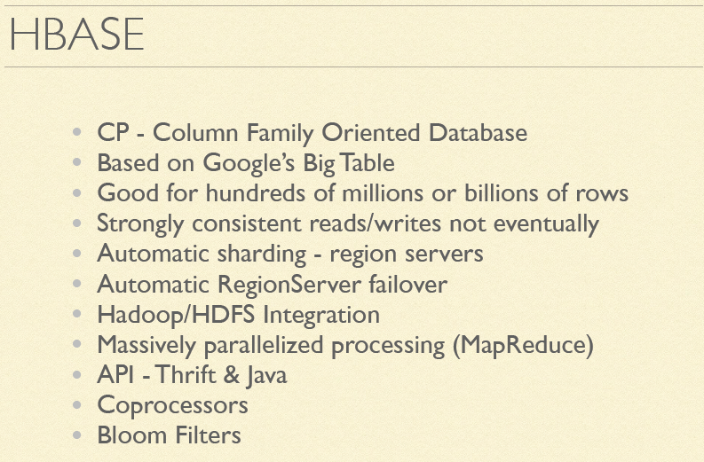

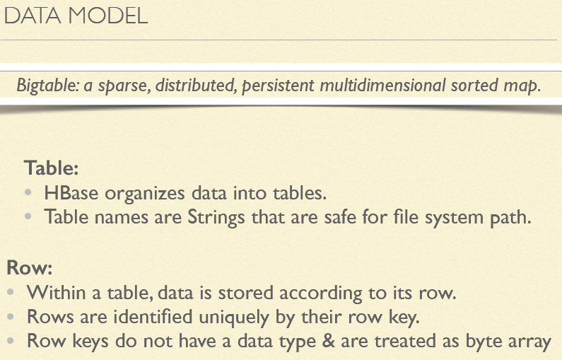

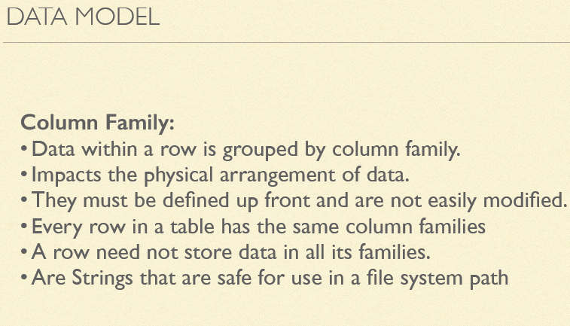

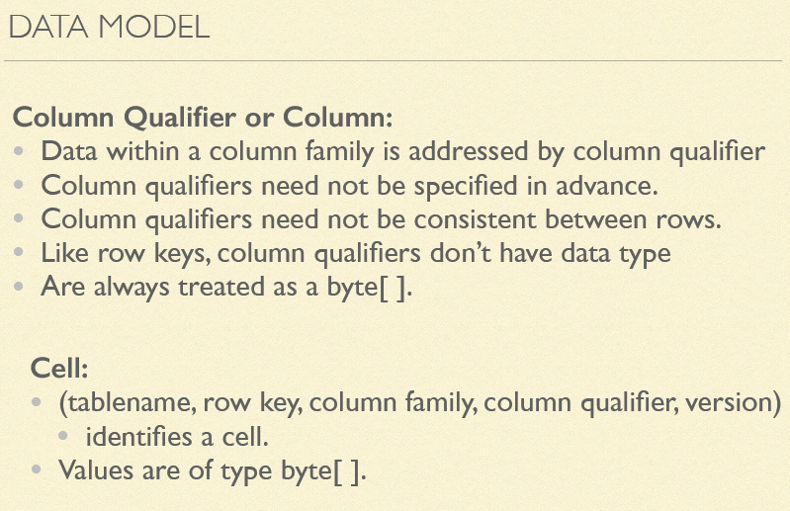

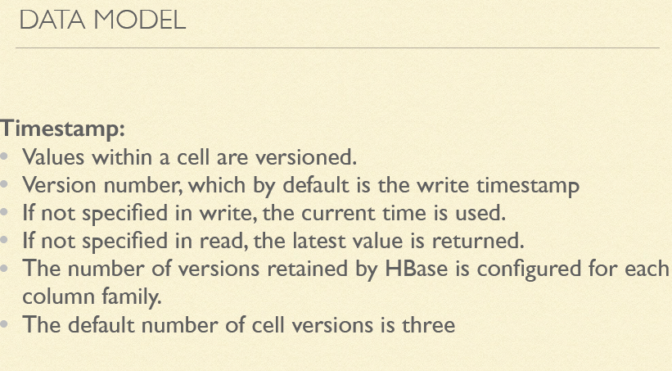

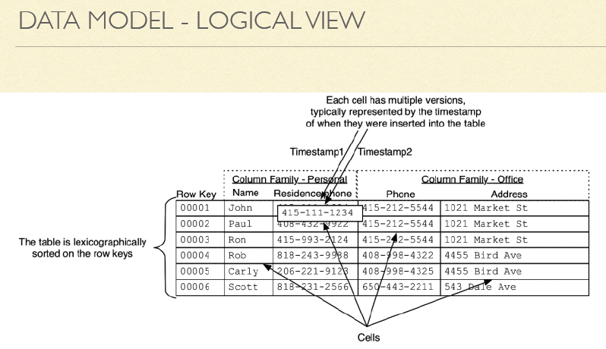

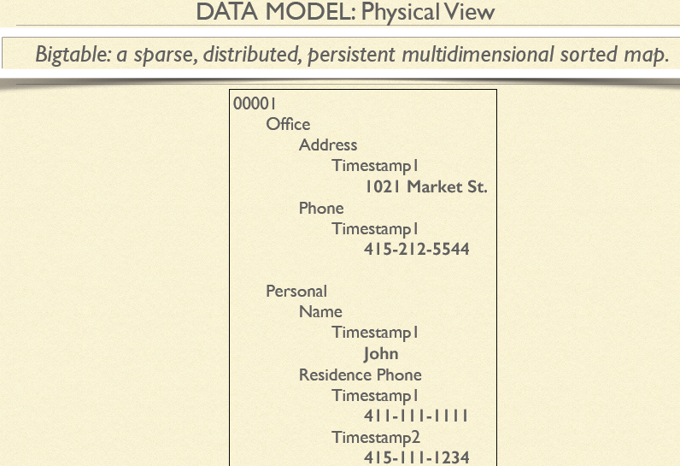

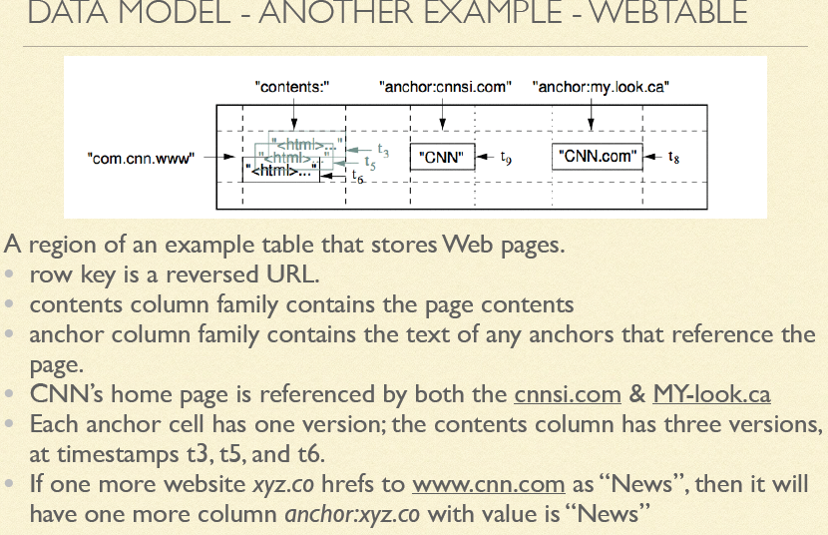

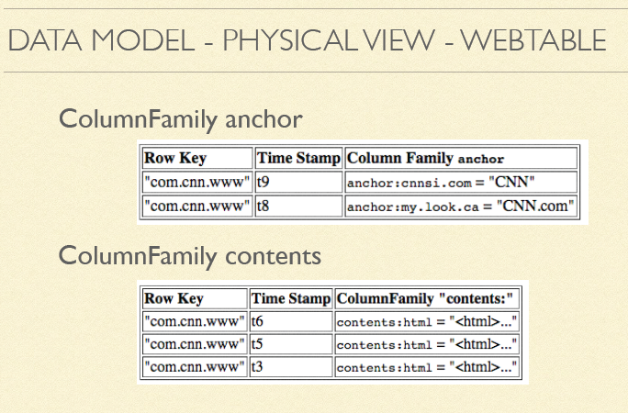

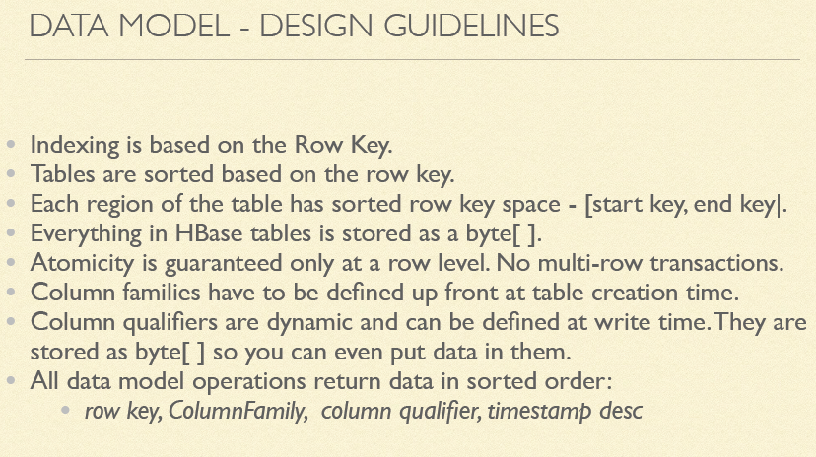

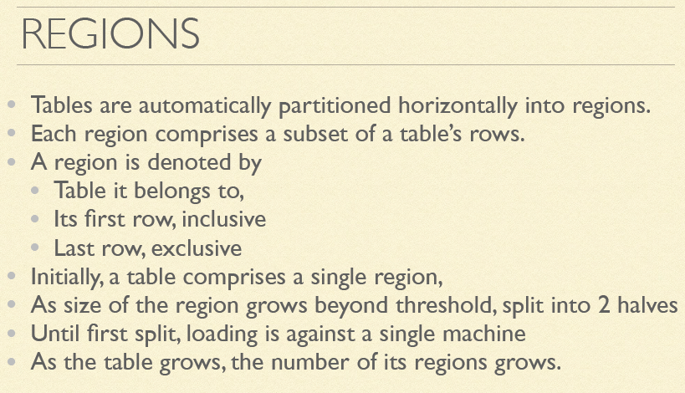

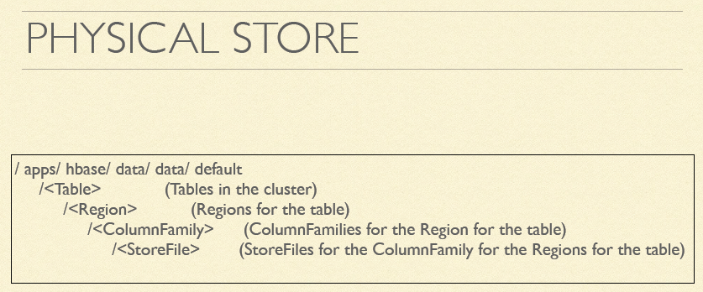

Sharding

The term sharding describes the logical separation of records into horizontal partitions.

The idea is to spread data across multiple storage files—or servers—as opposed to

having each stored contiguously.

Auto-Sharding

The basic unit of scalability and load balancing in HBase is called a region. Regions are

essentially contiguous ranges of rows stored together. They are dynamically split by

the system when they become too large. Alternatively, they may also be merged to

reduce their number and required storage files

Initially there is only one region for a table, and as you start adding data to it, the system

is monitoring it to ensure that you do not exceed a configured maximum size. If you

exceed the limit, the region is split into two at the middle key—the row key in the middle

of the region—creating two roughly equal halves

Each region is served by exactly one region server, and each of these servers can serve many regions at any time. Figure 1-7 shows how the logical view of a table is actually a set of regions hosted by many region servers.



For HBase and modern hardware, the number would be more like 10 to 1,000 regions per server, but each between 1 GB and 2 GB in size.

Splitting and serving regions can be thought of as autosharding, as offered by other

systems. The regions allow for fast recovery when a server fails, and fine-grained load

balancing since they can be moved between servers when the load of the server currently serving the region is under pressure, or if that server becomes unavailable because of a failure or because it is being decommissioned.

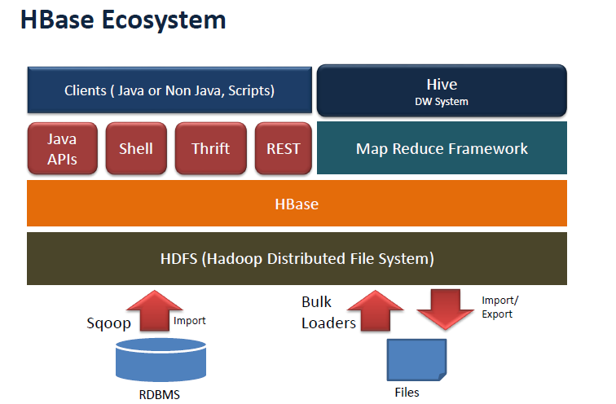

Implementation



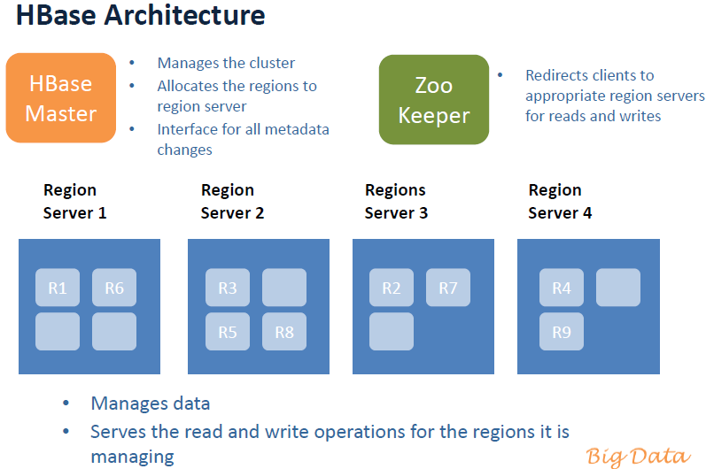

There are three major components to HBase: the client library, one master server, and

many region servers. The region servers can be added or removed while the system is

up and running to accommodate changing workloads. The master is responsible for

assigning regions to region servers and uses Apache ZooKeeper, a reliable, highly available, persistent and distributed coordination service, to facilitate that task.

The master server is also responsible for handling load balancing of regions across

region servers, to unload busy servers and move regions to less occupied ones. The

master is not part of the actual data storage or retrieval path. It negotiates load balancing and maintains the state of the cluster, but never provides any data services to either the region servers or the clients, and is therefore lightly loaded in practice. In addition, it takes care of schema changes and other metadata operations, such as creation of tables and column families.

Region servers are responsible for all read and write requests for all regions they serve,

and also split regions that have exceeded the configured region size thresholds. Clients

communicate directly with them to handle all data-related operations.

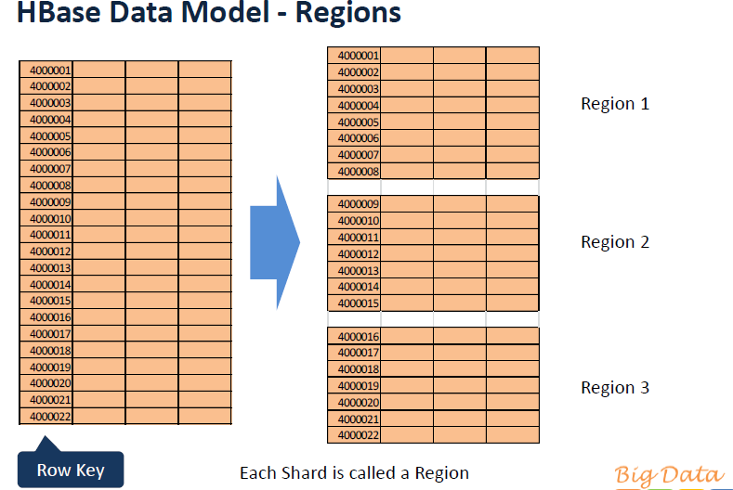

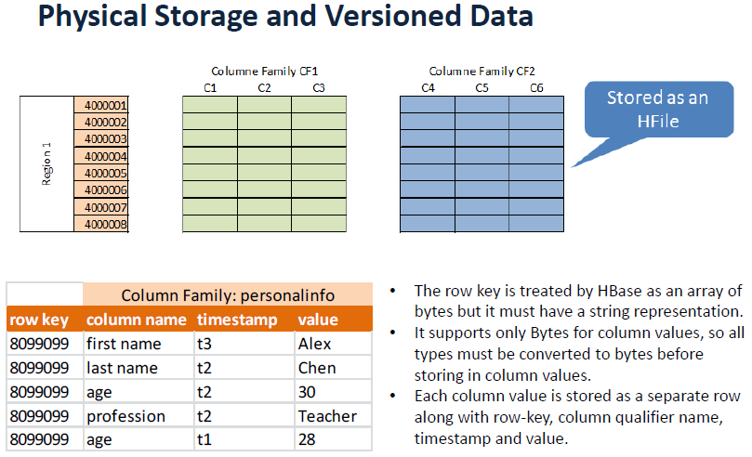

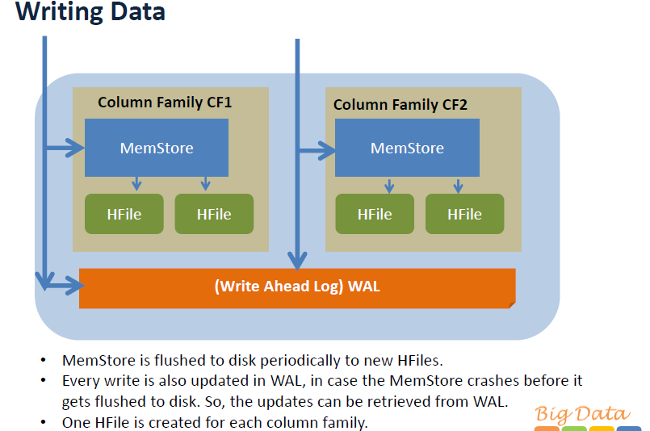

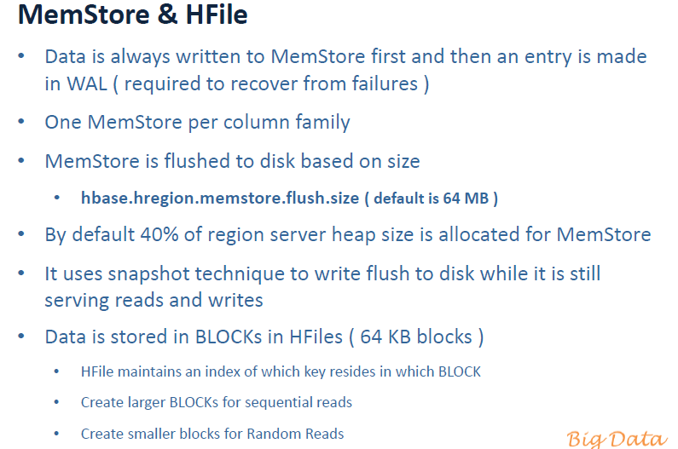

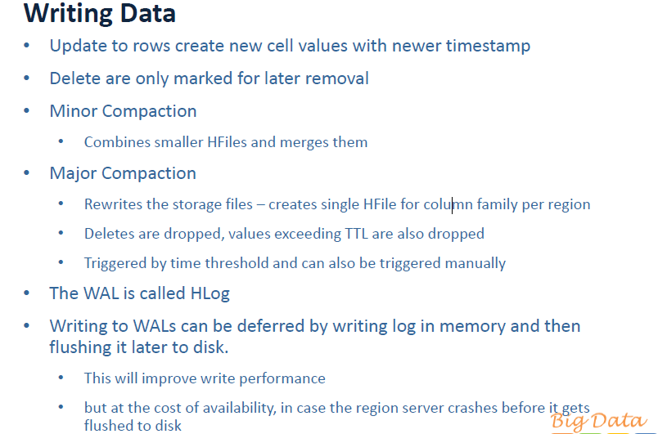

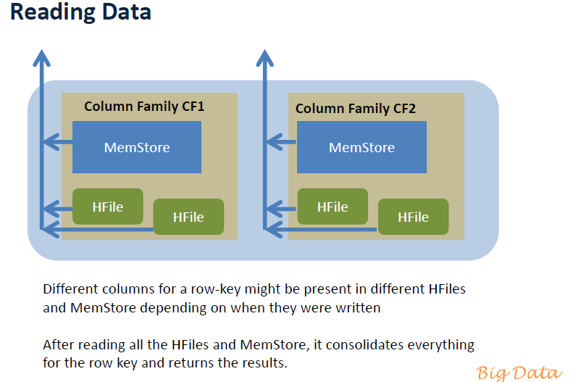

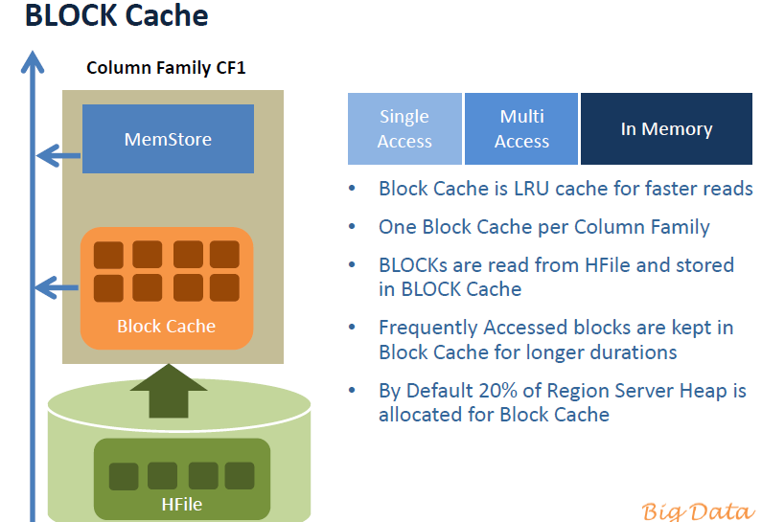

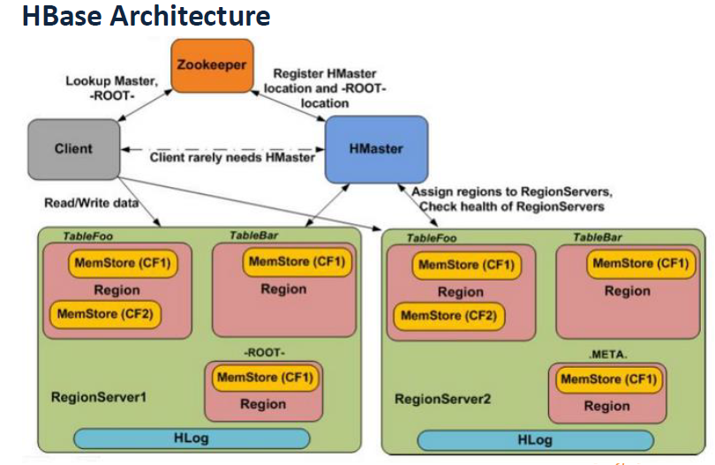

The data is stored in store files, called HFiles, which are persistent and ordered immutable maps from keys to values. Internally, the files are sequences of blocks with a block index stored at the end. The index is loaded when the HFile is opened and kept in

memory. The default block size is 64 KB but can be configured differently if required.

The store files provide an API to access specific values as well as to scan ranges of values given a start and end key.

Since every HFile has a block index, lookups can be performed with a single disk seek.

First, the block possibly containing the given key is determined by doing a binary search

in the in-memory block index, followed by a block read from disk to find the actual key.

The store files are typically saved in the Hadoop Distributed File System (HDFS), which

provides a scalable, persistent, replicated storage layer for HBase. It guarantees that

data is never lost by writing the changes across a configurable number of physical

servers.

When data is updated it is first written to a commit log, called a write-ahead log (WAL)

in HBase, and then stored in the in-memory memstore. Once the data in memory has

exceeded a given maximum value, it is flushed as an HFile to disk. After the flush, the

commit logs can be discarded up to the last unflushed modification. While the system

is flushing the memstore to disk, it can continue to serve readers and writers without

having to block them. This is achieved by rolling the memstore in memory where the

new/empty one is taking the updates, while the old/full one is converted into a file.

Note that the data in the memstores is already sorted by keys matching exactly what

HFiles represent on disk, so no sorting or other special processing has to be performed.

Because store files are immutable, you cannot simply delete values by removing the

key/value pair from them. Instead, a delete marker (also known as a tombstone marker)

is written to indicate the fact that the given key has been deleted. During the retrieval process, these delete markers mask out the actual values and hide them from reading clients.

Reading data back involves a merge of what is stored in the memstores, that is, the data that has not been written to disk, and the on-disk store files. Note that the WAL is

never used during data retrieval, but solely for recovery purposes when a server has

crashed before writing the in-memory data to disk.

Since flushing memstores to disk causes more and more HFiles to be created, HBase

has a housekeeping mechanism that merges the files into larger ones using compaction.

There are two types of compaction: minor compactions and major compactions.

The former reduce the number of storage files by rewriting smaller files into fewer but

larger ones, performing an n-way merge. Since all the data is already sorted in each

HFile, that merge is fast and bound only by disk I/O performance.

The major compactions rewrite all files within a column family for a region into a single

new one. They also have another distinct feature compared to the minor compactions:

based on the fact that they scan all key/value pairs, they can drop deleted entries including their deletion marker. Predicate deletes are handled here as well—for example, removing values that have expired according to the configured time-to-live or when there are too many versions.

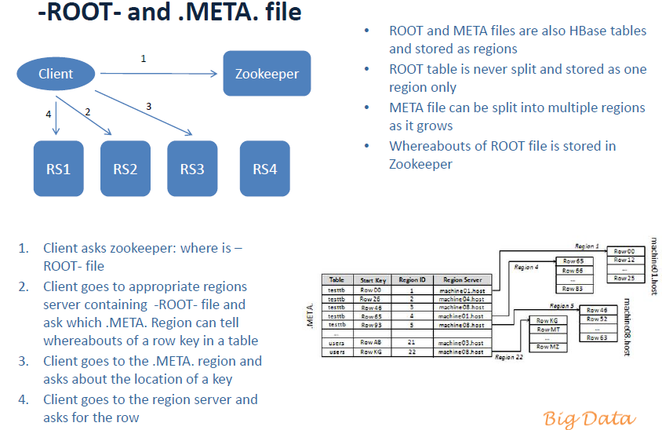

Apache ZooKeeper

It is used for,

* It offers filesystem-like access with directories and files (called *znodes*) that distributed systems can use to negotiate ownership, register services, or watch for updates.
* Every region server creates its own ephemeral node in ZooKeeper, which the master,in turn, uses to discover available servers. They are also used to track server failures or network partitions.
* HBase uses ZooKeeper also to ensure that there is only one master running, to store the bootstrap location for region discovery, as a registry for region servers, as well as for other purposes.

Servers

In HBase and Hadoop there are two types of machines: masters (the HDFS NameNode, the MapReduce JobTracker, and the HBase Master) and slaves (the HDFS DataNodes, the MapReduce TaskTrackers, and the HBase RegionServers).

Datanode handlers

A Hadoop HDFS data node has an upper bound on the number of files that it will serve

at any one time. The upper bound parameter is called xcievers (yes, this is misspelled).

Again, before doing any loading, make sure you have configured Hadoop’s conf/hdfssite. xml file, setting the xcievers value to at least the following:

<property>

<name>dfs.datanode.max.xcievers</name>

<value>4096</value>

</property

Filesystems for HBase



Local

The *local* filesystem actually bypasses Hadoop entirely, that is, you do not need to have

an HDFS or any other cluster at all. It is handled all in the FileSystem class used by

HBase to connect to the filesystem implementation. The *standalone mode* of HBase uses this feature to run HBase only. You can select it by using the following scheme:

file:///<path>

HDFS

The *Hadoop Distributed File System* (HDFS) is the default filesystem when deploying

a fully distributed cluster.

S3

Amazon’s *Simple Storage Service* (S3)# is a storage system that is primarily used in

combination with dynamic servers running on Amazon’s complementary service

named *Elastic Compute Cloud* (EC2).*

You can select the filesystem using these URIs:

s3://<bucket-name>

s3n://<bucket-name>

Run Modes

HBase has two run modes: *standalone* and *distributed*. Out of the box, HBase runs in

standalone mode, as seen in “Quick-Start Guide” on page 31. To set up HBase in

distributed mode, you will need to edit files in the HBase *conf* directory.

Whatever your mode, you may need to edit *conf/hbase-env.sh* to tell HBase which

*java* to use. In this file, you set HBase environment variables such as the heap size and

other options for the JVM, the preferred location for logfiles, and so on. Set

JAVA_HOME to point at the root of your *java* installation.

Standalone Mode

This is the default mode, as described and used in “Quick-Start Guide” on page 31. In

standalone mode, HBase does not use HDFS—it uses the local filesystem instead—and

it runs all HBase daemons and a local ZooKeeper in the same JVM process. ZooKeeper

binds to a well-known port so that clients may talk to HBase.

Distributed Mode

The *distributed mode* can be further subdivided into *pseudodistributed*—all daemons

run on a single node—and *fully distributed*—where the daemons are spread across

multiple, physical servers in the cluster.‖

Client API: The Basics

The primary client interface to HBase is the HTable class in the org.apache.hadoop.

hbase.client package. It provides the user with all the functionality needed to store

and retrieve data from HBase as well as delete obsolete values and so on

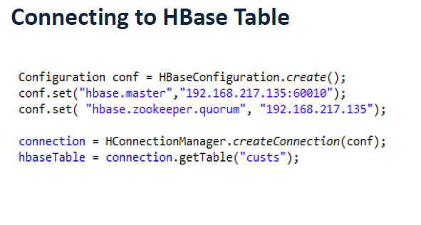

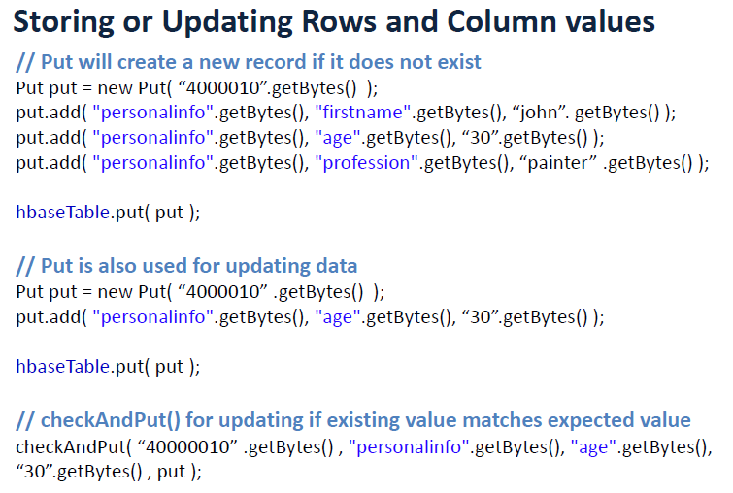

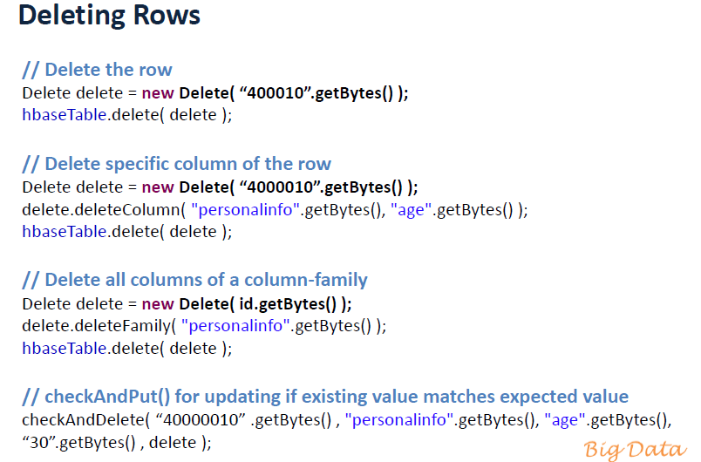

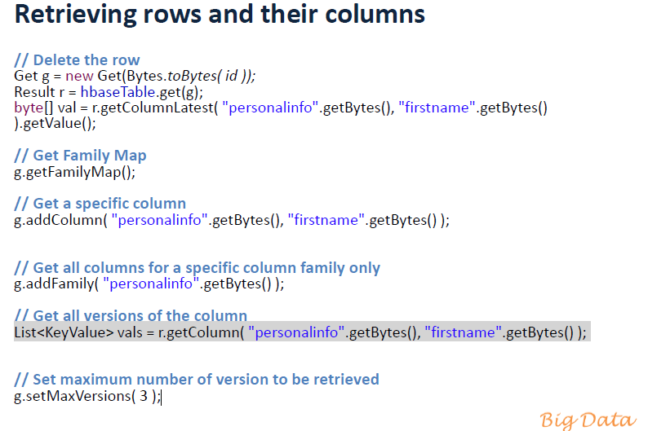

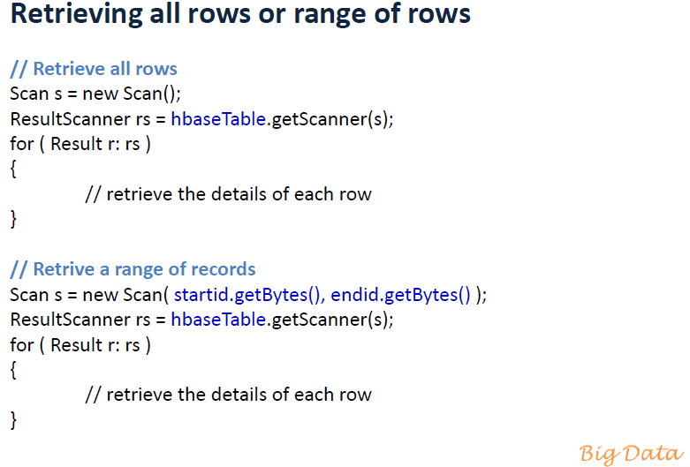

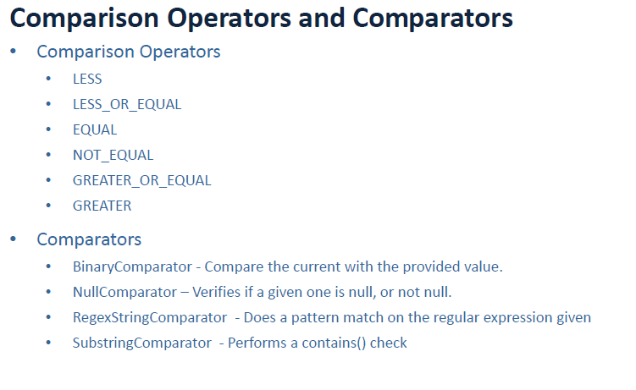

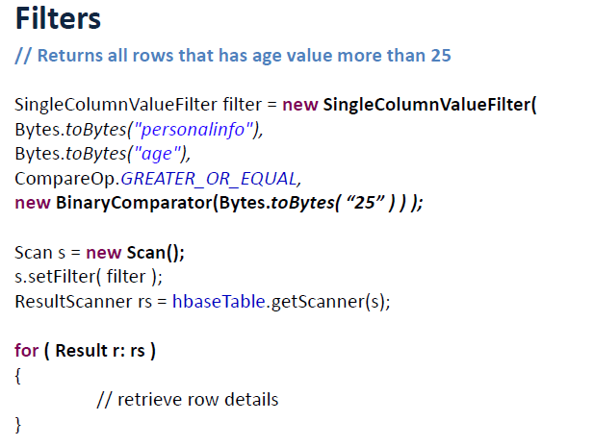

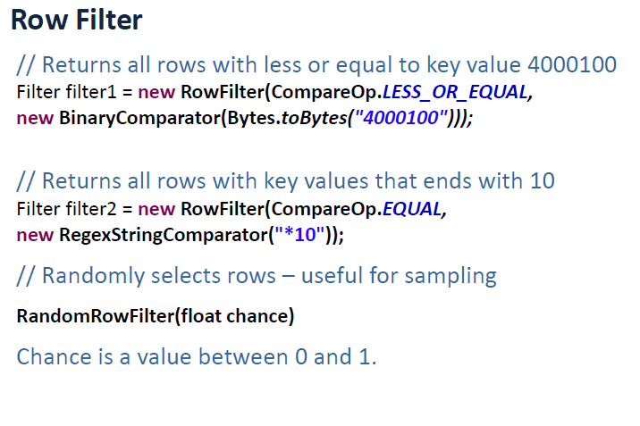

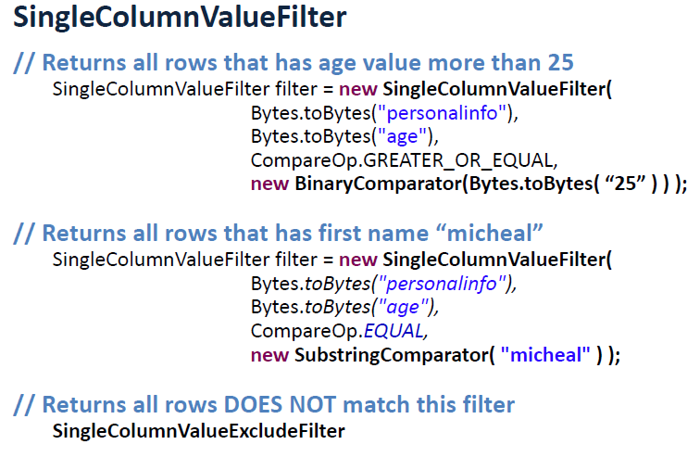

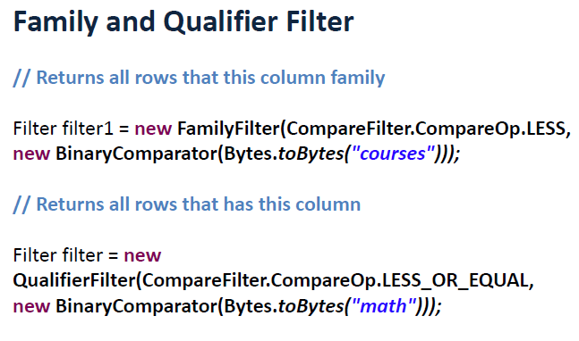

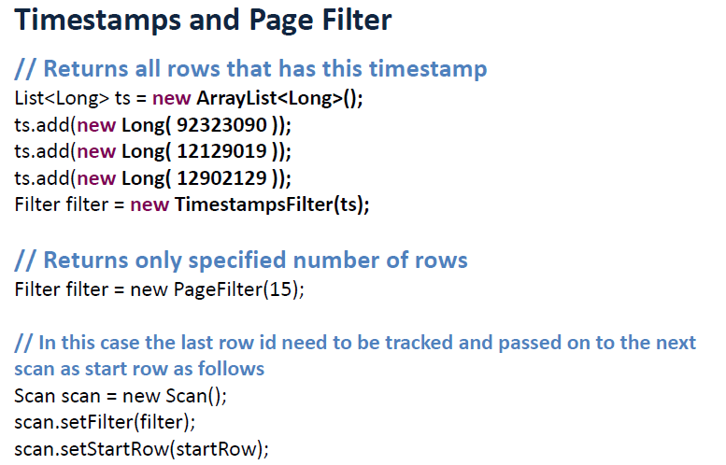

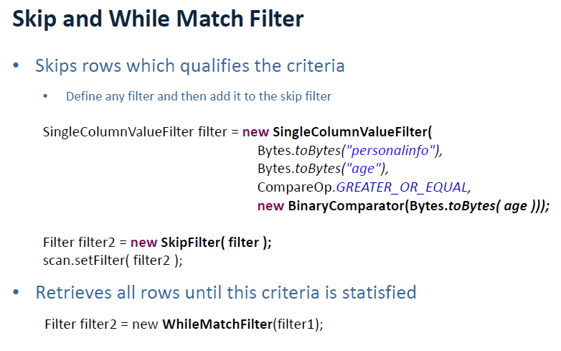

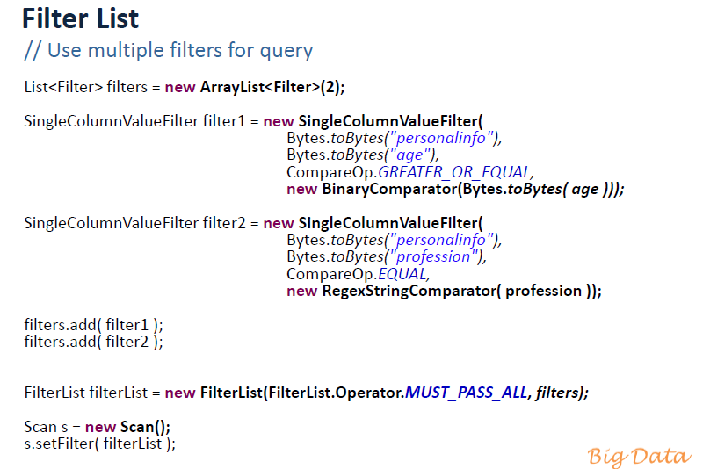

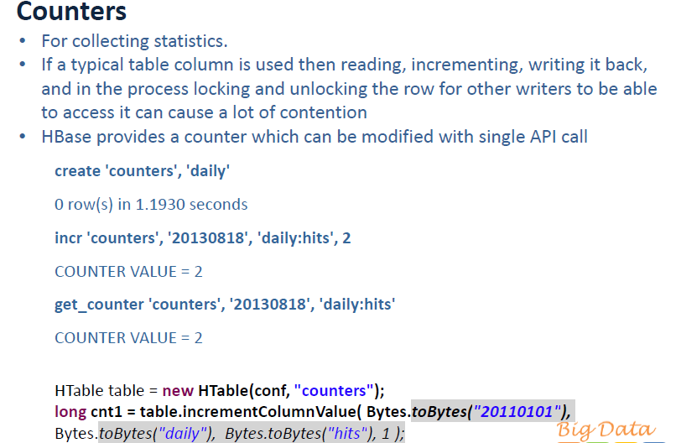

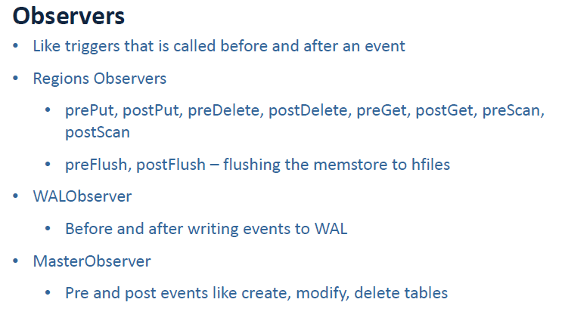

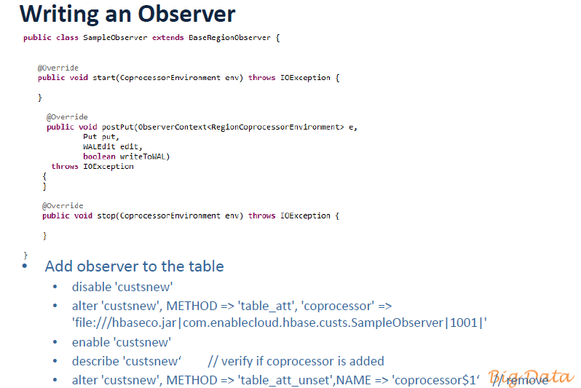

Available Clients



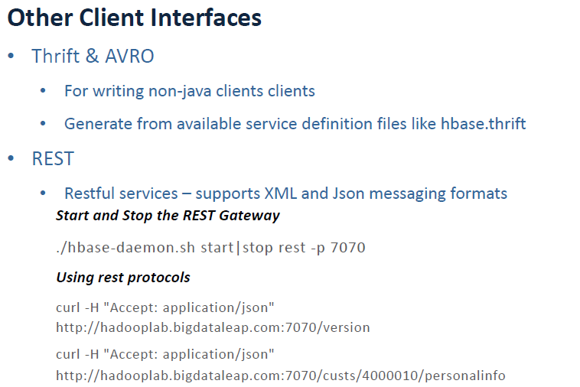

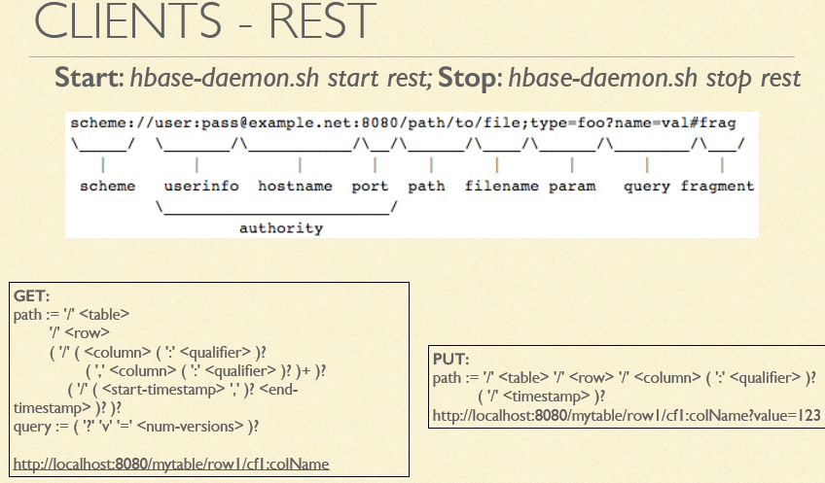

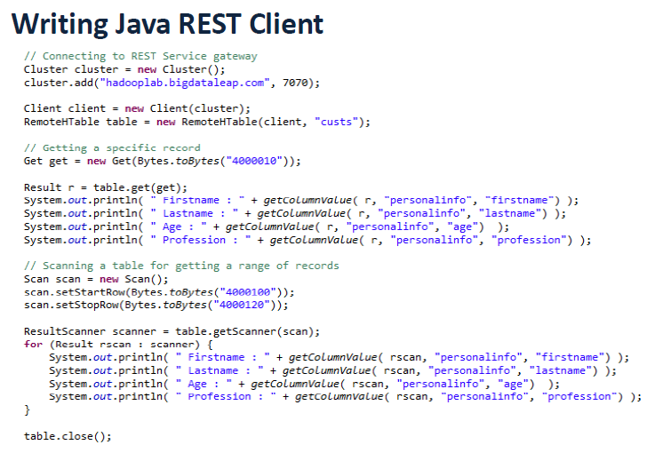

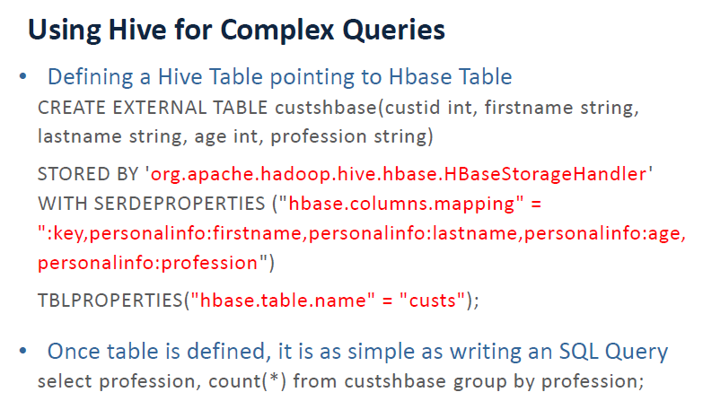

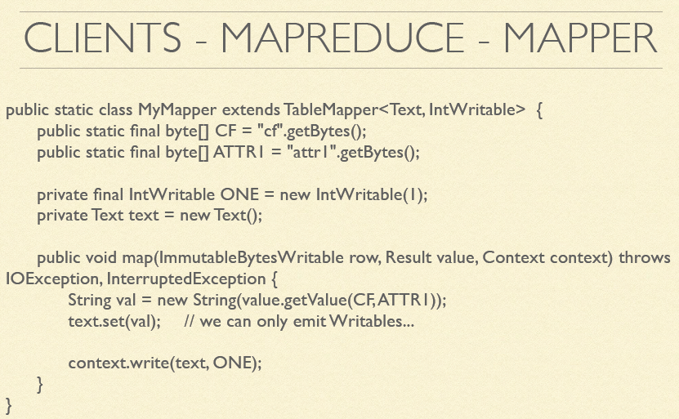

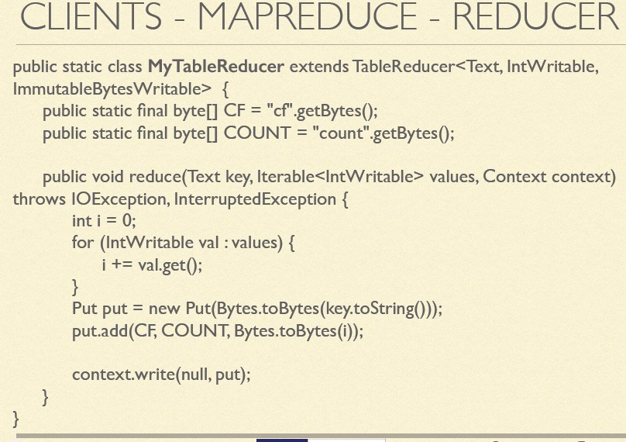

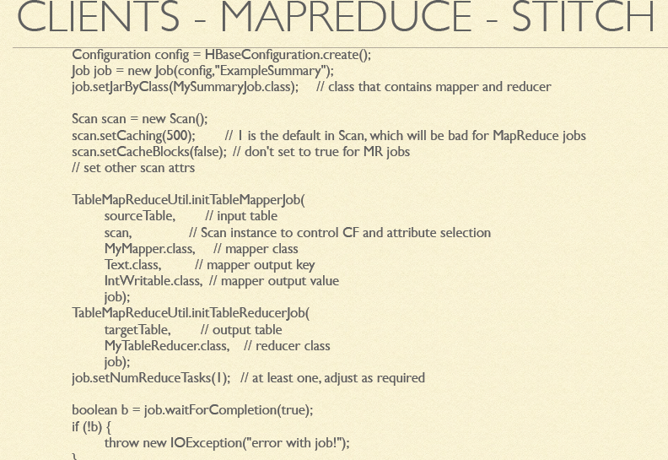

Pig

Pig also can be used for load and read data from HBase.

Shell

Shell commands

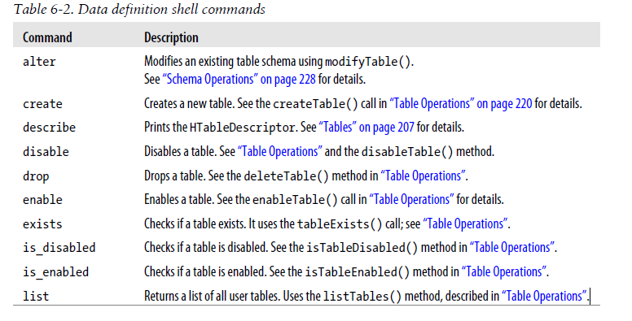

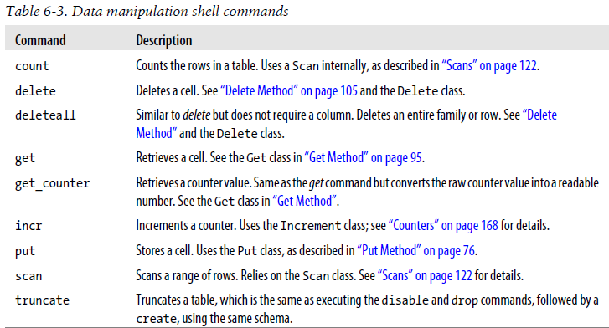

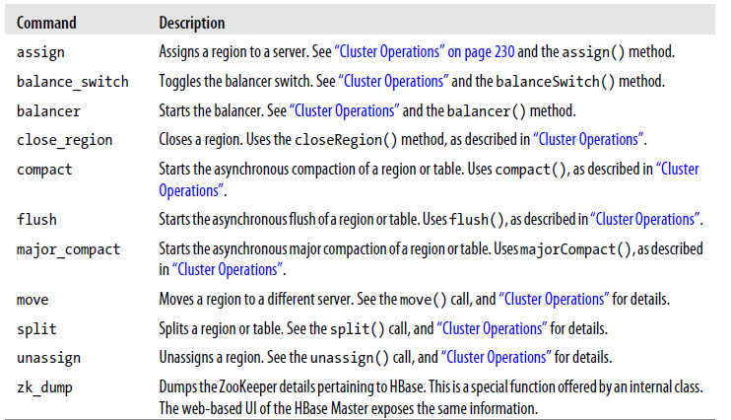

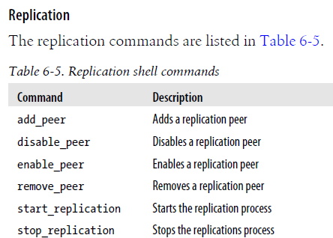

Designing HBase Schema

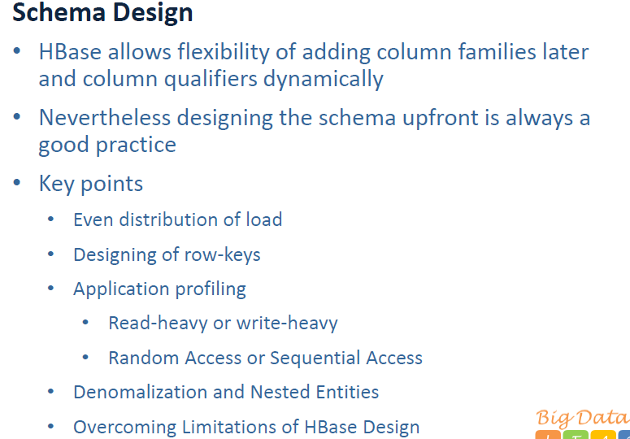

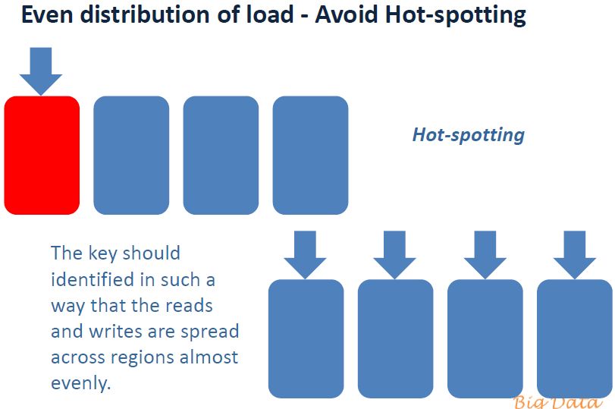

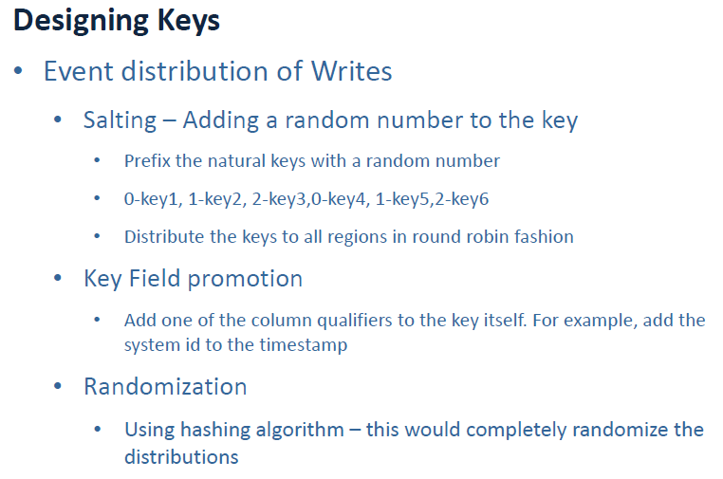

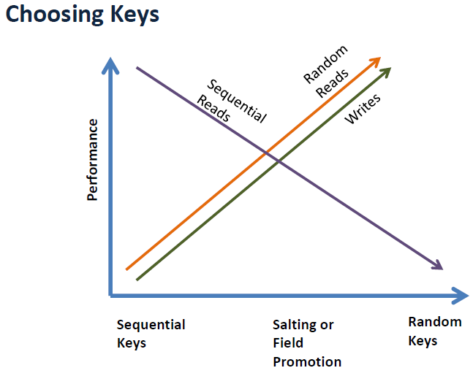

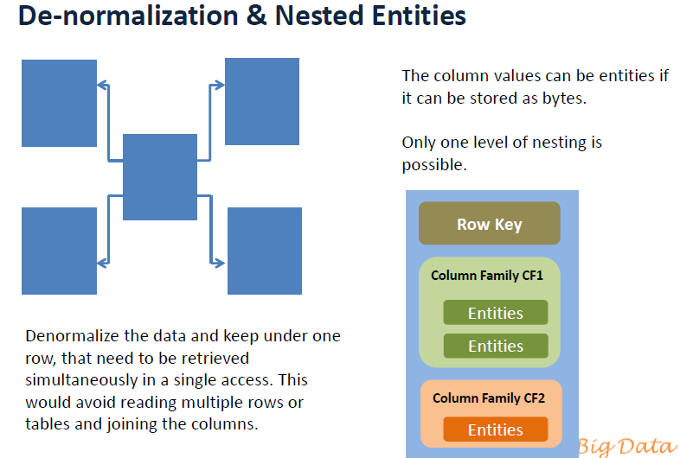

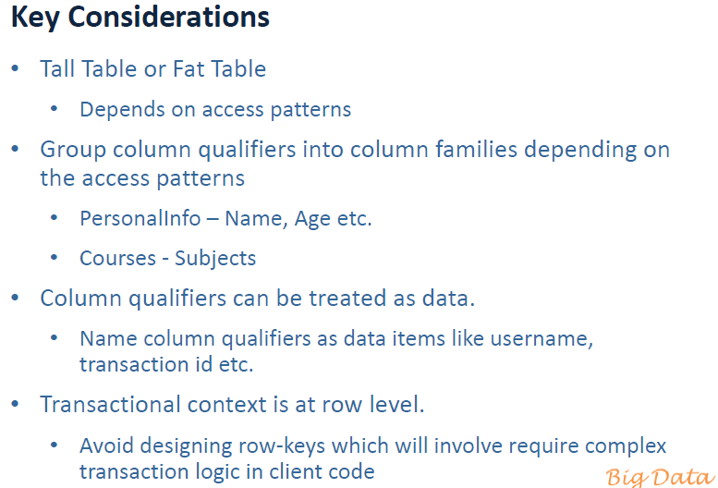

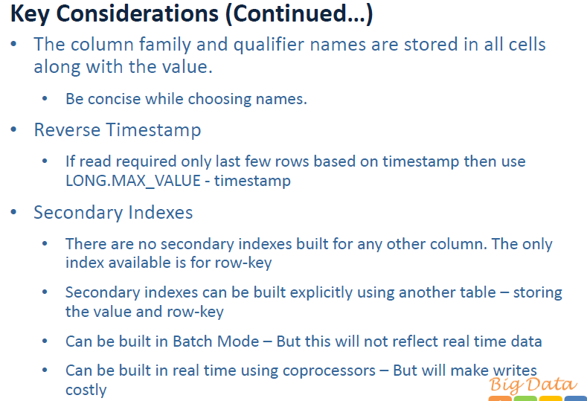

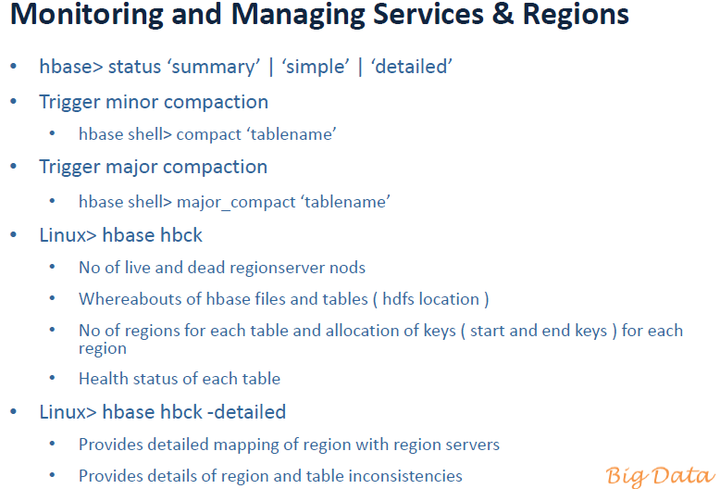

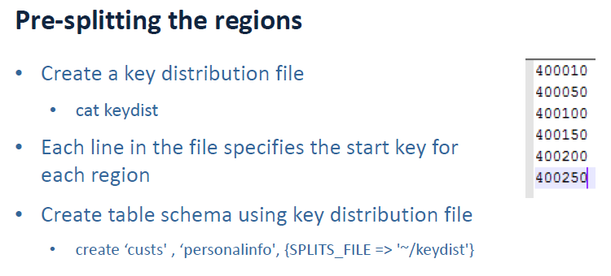

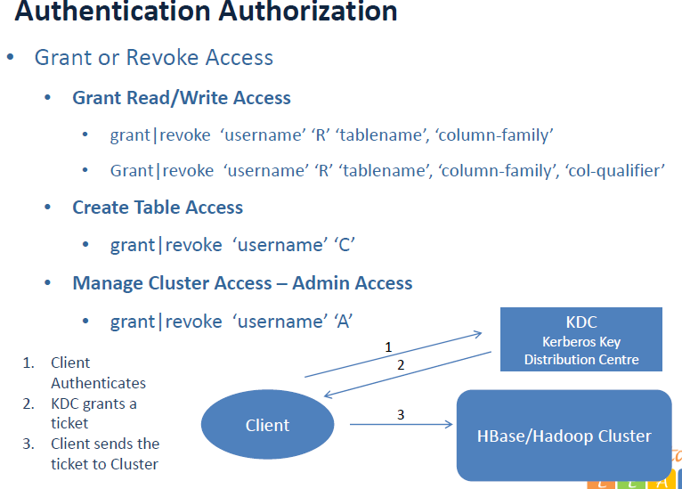

Performance Tuning

